Make sure to install **Git** and **Visual Studio Code**

Setup (Only Local):

Open Anaconda prompt, then in the prompt:

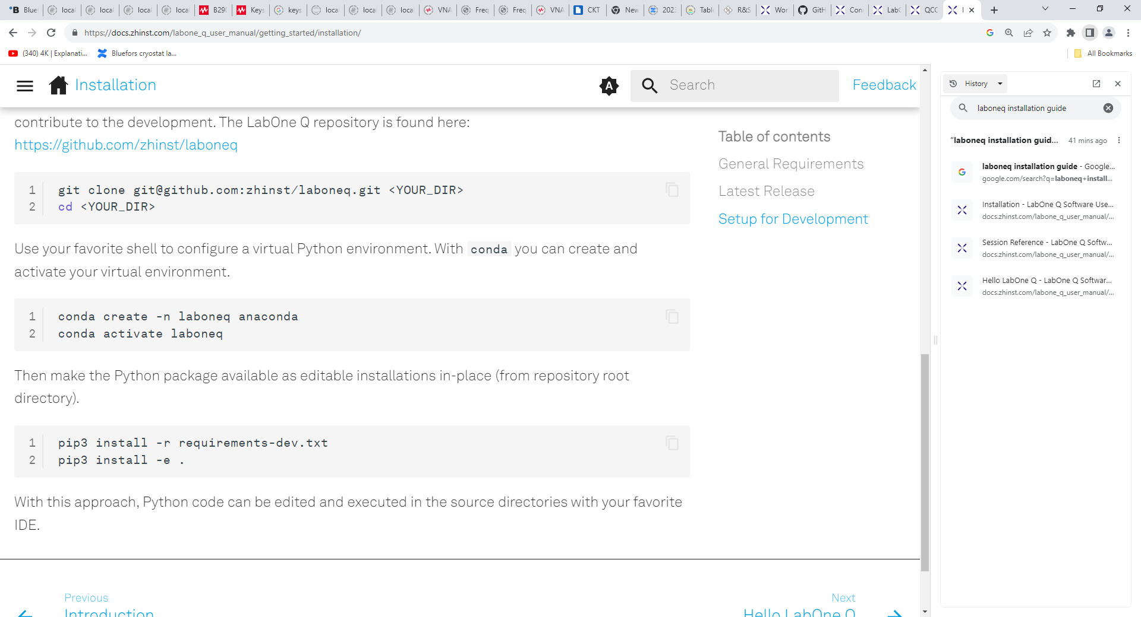

Afterwards:

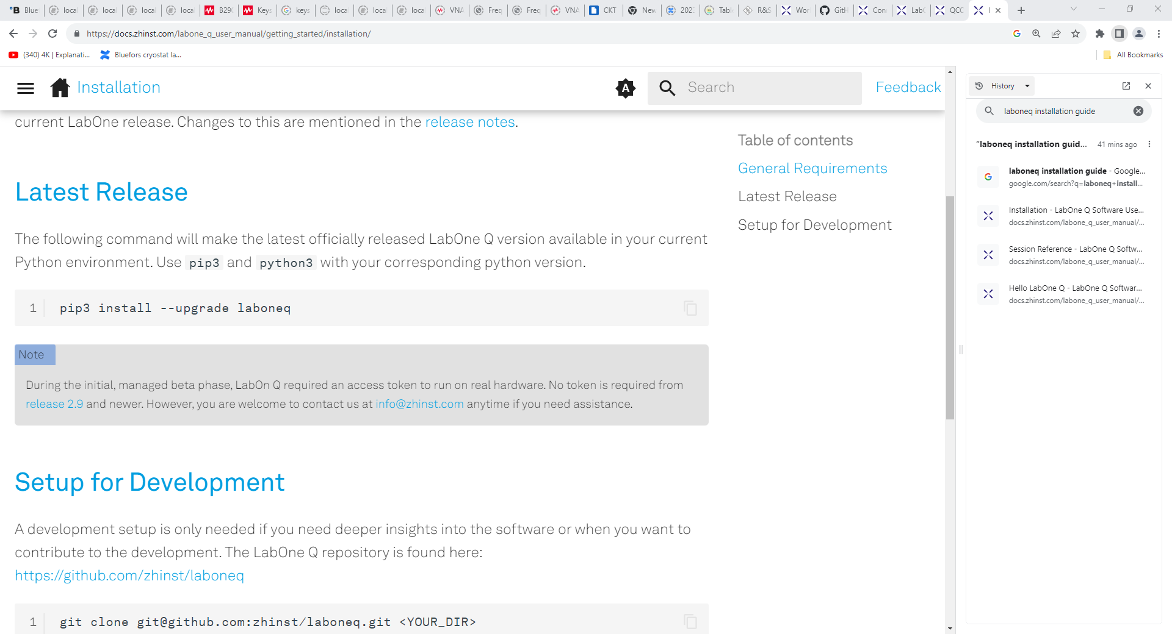

Finally: from the Anaconda prompt (with the env selected and all packages installed) run “code” to open VSC

**Env name: laboneq_dev**

“Global” Installation:

Fork repository into your Github Account and then run all the steps above

Then in VSC create a branch for your changes and commit and push (to forked repository) after changes

Master can then decide which changes to pull

You should then be able to create your own notebooks and use all the modules from laboneq and to also work with all the examples provided

**System Architecture**

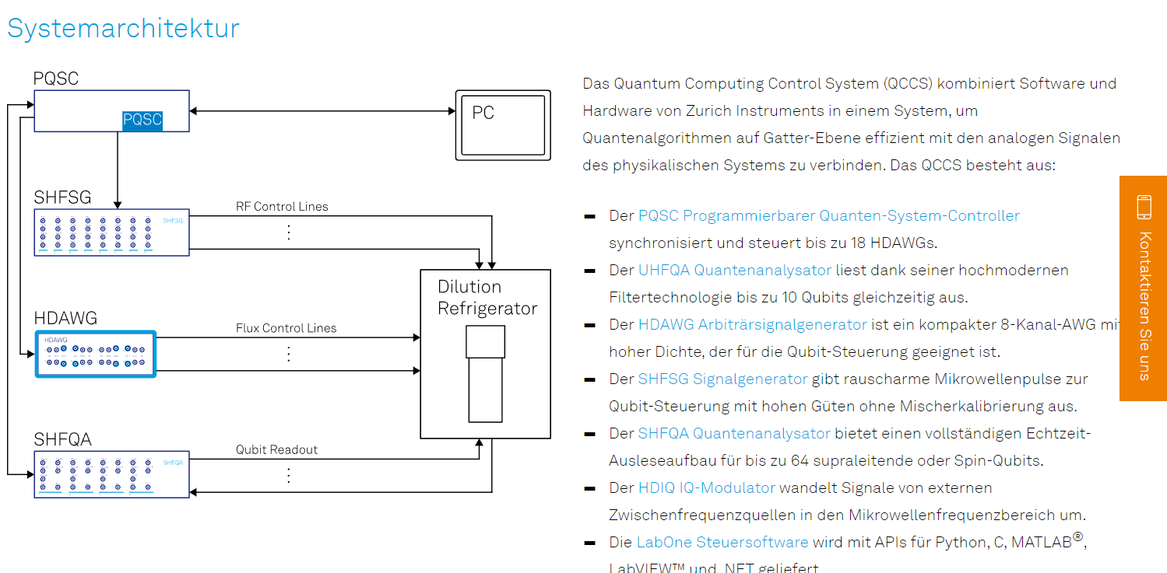

**Software Architecture**

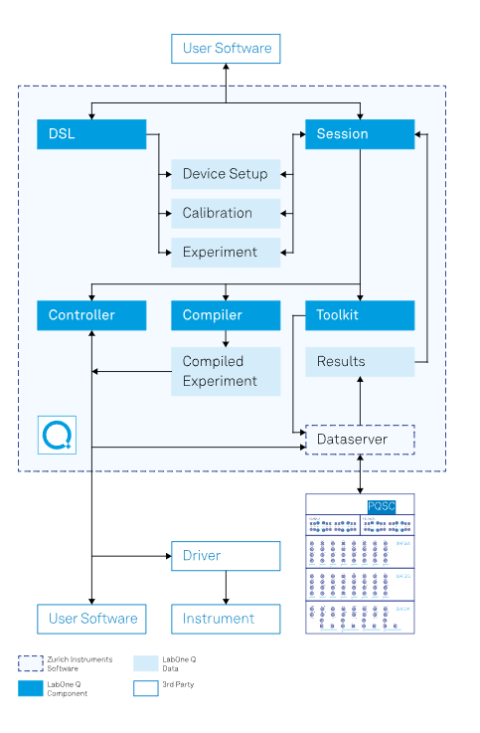

Dataserver is provided by LabOne Software

The QCCS Monitor can be found under:

T:\MQV Cryo-Team\0 Measurements\1 Measurement scripts\QCCS Monitor\qccs-monitor-windows-x86_64-23.06.46756

**Starting the server:**

In the terminal and at the according location run:

.\bin\qccs-monitor-server.exe --resdir=.\res -p 9000 .\config\my_setup.json

With these settings, the webserver can be accessed at http://127.0.0.1:9000, if the monitor server and the browser are running on the same machine. Otherwise, replace 127.0.0.1 with the domain name or IP address of the host.

Overview of commands: .\bin\qccs-monitor-server.exe –help

Terminate the monitor server by pressing: CTRL+C

**Configuring the server:**

If you want to change the **configuration** of the monitor edit the my_setup.json file in the config folder

Connect to the server in LabOne and remember the **Host address**

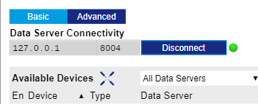

Have the same address in your setup JSON File

Then run this code while **replacing 8004 with your port address if it differs and the device IDs:**

**.\bin\qccs-monitor-server.exe --resdir=.\res -p 9000 .\config\my_setup.json**

**Since the host addr is not 127.0.0.1 we have to change the command for the LAB PC to:**

**(You can find all IP addr in cmd with ipconfig /all)**

**Command: .\bin\qccs-monitor-server.exe --resdir=.\res -p 9000 .\config\my_setup.json --addr 169.254.247.50**

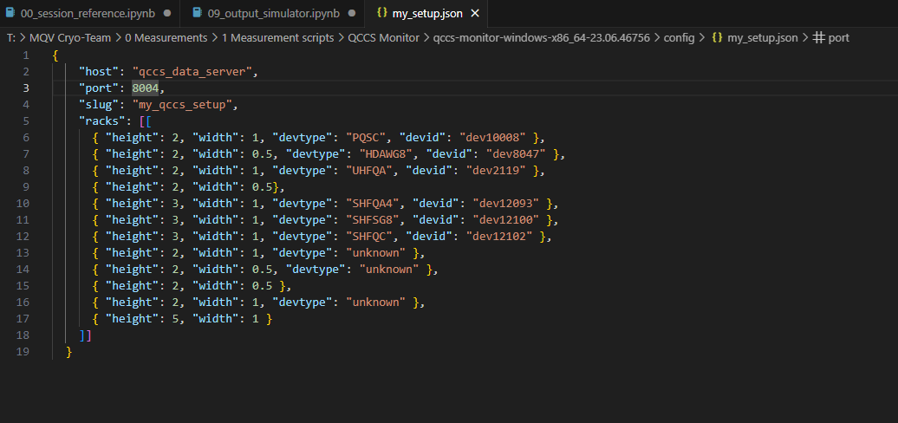

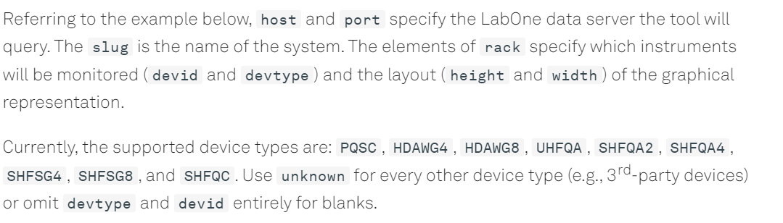

You can terminate the monitor server by pressing CTRL+C.

Note:

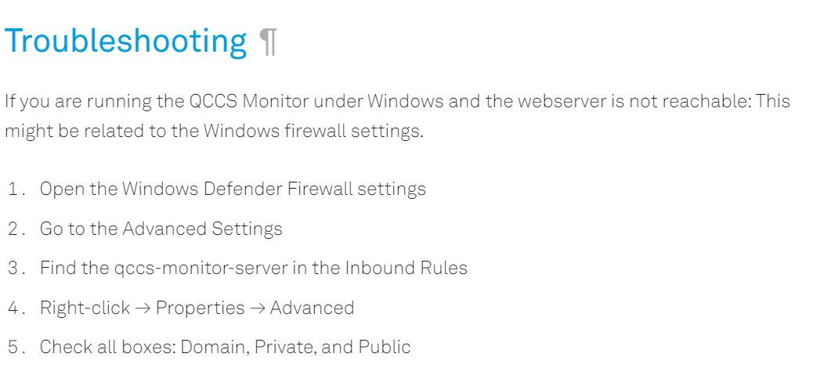

QA and SG are being combined

SG has IQ Modulation inside to get the appropriate signal (instead of just combining rec with sinus)

Try to get the QA to do a signal sweep for the resonators like the VNA does